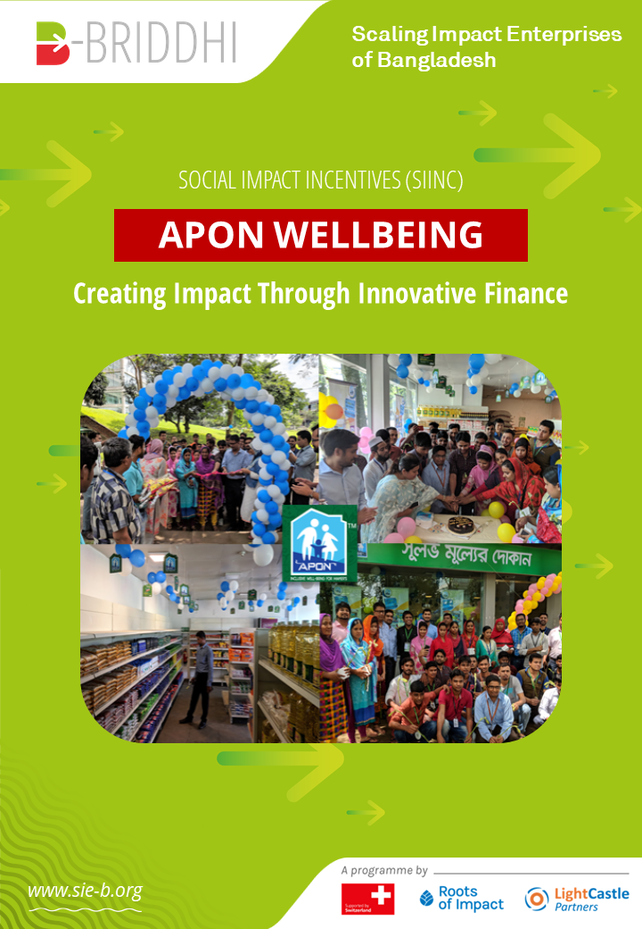

**Table of Contents**

Introduction to Biniyog Briddhi (“B-Briddhi”) 3

Apon Wellbeing: The Social Omnichannel Marketplace 4

Target Population, Market and Needs 5

Deeper Dive into the Social Problem 6

Solutions and Opportunities 7

Traction 7

Social Impact 8

Empowered by Social Impact Incentives 9

Way Forward 10

# Introduction to Biniyog Briddhi (“B-Briddhi”)

Bangladesh is on an ambitious growth path, transforming the country to a digital and knowledge economy poised to be the 24th largest in the world by 2030 (*World Economic Forum*). A key goal is to develop an inclusive ecosystem, which allows the entire population to participate in this growth. Impact enterprises can play a vital role in this vision. By developing and scaling innovative solutions to social and environmental challenges, people still living in disadvantaged conditions receive an equal chance to benefit from economic prosperity in their roles as customers, suppliers and employees.

In an attempt to mitigate the market failures that surround impact enterprises, [Biniyog Briddhi (“B-Briddhi”)](https://www.sie-b.org/), a multi-year programme, was formed in 2019 under a public-private development partnership between the Swiss Agency for Development and Cooperation, Roots of Impact, and LightCastle Partners. The programme intends to enhance the impact enterprises' **financial, social** and **environmental**performance by enabling them to master **investment readiness** as well as**impact measurement and management.** In addition, it gives impact enterprises a much-needed access to **innovative and catalytic funding,** which puts them in a much better position to scale their impact.

**B-Briddhi is a multi-year public-private development partnership (PPDP) between the Swiss Agency for Development and Cooperation, Roots of Impact, LightCastle Partners and other stakeholders, including investors, private sector organizations, incubators, and support organizations for impact enterprises.**

B-Briddhi tackles essential factors on both the supply and demand sides of impact finance. The objective is to contribute to an ecosystem in which impact entrepreneurs have increased access to suitable growth capital and investors receive exposure to a pipeline of investment-ready impact enterprises. The project's overall aims include:

1. improving the livelihoods of several hundred thousands of people living in poverty and including them in their roles as customers, suppliers, and workers of impact enterprises,
2. increasing the financial, social, and environmental performance of impact enterprises, which includes preparing them for investment, assisting them in growing successfully and in managing, measuring, and improving their social impact, as well as inspiring and preparing investors towards investing in impact,
3. creating better framework conditions for impact enterprises in Bangladesh in general, wherever possible.

B-Briddhi’s primary actions are organized around three pillars of activity that serve as the programme's backbone. The first pillar, **capacity building**, addresses the demand by impact enterprises for high-quality services: By building the capacities of local incubators, specifically with respect to impact measurement and management and investment readiness, the goal is to create a local ecosystem that supports impact enterprises to become ready to access, secure, and use impact investment.

The second pillar builds on **catalytic funding**. There are two innovative financing instruments deployed in B.Briddhi: [Social Impact Incentives (SIINC)](https://www.sie-b.org/social-impact-incentives/) as well as [Impact-Ready Matching Funds](https://www.sie-b.org/impact-ready-matching-fund/) (IRMF). SIINC rewards high-impact enterprises with time-limited premium payments for achieving social impact. This allows impact enterprises to receive an additional revenue stream and thus get a better chance at securing investment. It also enables the enterprises to stay true to their social missions and realize their full impact potential. IRMF is another innovative financing instrument, which is used for the very first time within the B-Briddhi programme. IRMF is a non-repayable funding that rewards impact entrepreneurs for building their capacities in impact management and measurement. This creates more transparency around how to best create impact for their beneficiaries and also helps to increase attractiveness vis-a-vis impact-minded investors.

The third pillar, **advocacy**, focuses on identifying and assisting local public and private stakeholders in Bangladesh with the goal of creating an enabling climate for impact investing and impact entrepreneurship.

In April 2021, B-Briddhi teamed up with [**Apon Wellbeing**](https://www.apon-wellbeing.com/) to provide the impact enterprise with financial support in the form of Social Impact Incentives (SIINC).

# Apon Wellbeing: The Social Omnichannel Marketplace

**Founded by Saif Rashid, Apon Wellbeing focuses on enhancing the lives of factory workers by providing goods and services at affordable and fair prices, thus enabling more disposable income for savings.**

The ready-made garment (RMG) industry accounts for more than 80% of the export income of Bangladesh, with nearly four million people working towards the success of this industry. Apon Wellbeing was established in 2017 to make a difference for these mass underprivileged RMG workers, whose low wages leave them with only meagre disposable income.

Despite working full time, the majority of factory workers are living in poverty as their real wage is much lower than the country’s average (USD 2,227 per capita in 2020-21). To increase these real wages, Apon Wellbeing is setting up commissaries on RMG factory premises, where they offer groceries and health nutrition products at reduced prices (typically 10% below retail prices). Apart from providing low-cost everyday items, the impact enterprise also facilitates better financial inclusion by providing workers with interest-free credit facilities and health insurance benefits. This has resulted in behavioural changes as workers are getting basic health checks, which leads to improved work attendance and more income (since workers are paid daily wages).

The Apon Wellbeing model empowers workers, especially women, who represent 44% of the 70,000 workers that the enterprise is reaching today. Apon improves the lives of these 70,000 workers through 19 proprietary discount shops in various factories and has generated total savings of more than USD 130,000 to date. So far, insurance coverage was provided to 9 percent of Apon Wellbeing’s customer base.

***Apon Wellbeing has received several awards and recognitions among industry giants. The impact enterprise has won the Tommy Hilfiger Fashion Frontier Challenge in 2019, the Inclusion Plus Bangladesh by MetLife Foundation in 2018, and the Expo Live’s Innovation Impact Grant at the Expo 2020 in Dubai.***

## Target Population, Market and Needs

Although Apon Wellbeing’s beneficiaries include both businesses and end consumers, its primary target customers are RMG workers with families, especially women. The impact enterprise covers mostly RMG factories in Dhaka City but also in some factories in Chattogram and Savar. The average age of target customers is 25.9 years (women: 25 years, men: 27 years), with 74% of them being married and having families.

The market size for Apon Wellbeing spans 3.6 million RMG workers throughout Bangladesh. Estimating that each worker spends around USD 55 for monthly grocery consumption, the total addressable market translates to a size of USD 2.4 Bn. There is a strong need for affordable products and services and an absence of provisions for health insurance in this market. Target customers are mostly motivated to purchase based on affordability, convenience and reliability, which Apon Wellbeing strives to address to create substantial positive impact.

*Figure: An illustrative depiction of Apon Wellbeing’s primary customer profile*

## Deeper Dive into the Social Problem

With a **monthly income of merely USD 100**, RMG workers in Bangladesh are losing up to **15%** of their income on healthcare payments, which translates into **BDT 1,283** every month. With a **year-over-year increase of 17% in living costs,** coupled with an insufficient income increase, this widens the alarming gap of available health care insurance policies for this essential part of the Bangladeshi workforce. On top of the increasing living costs, RMG workers spend another **56% of their monthly income** on groceries in order to feed their families.

While the retail chains currently present in the country are more focused towards the affluent or middle-income class population, - providing great offers, discounts, and often high-quality service, - there is an absence of specialized retail platforms (either online or physical) for the huge homogeneous population group of 3.6 million workers employed in more than 5,000 factories in Bangladesh.

Conventional mom-and-pop grocery stores do not take into account the wellbeing of the customers as they typically face problems such as price volatility, poor stocks, as well as inefficient and low-quality products. In addition, many grocery stores try to improve business by shelving more expensive high-end products and targeting urban markets and upper-middle/upper-class societies. Traditional markets underscore and ignore this vast market of workers in Bangladesh, which creates a huge potential for disruption and social impact that Apon Wellbeing strives to harness.

## Solutions and Opportunities

Apon Wellbeing’s business model is based on the ready-made garment industry's strong push for enhanced supply chain accountability. The model provides for a 360-degree wellbeing to workers, with a specific focus on women. First, the impact enterprise sets up grocery stores within the factory premises together with the shop owners. Then an awareness program is initiated to communicate the benefits and processes to the beneficiaries. In the next step, workers receive shopping cards with credit limits, which they can use to start buying goods and services.

There are strong opportunities for the enterprise to create more impact through financial inclusion schemes. Apon Wellbeing facilitates this inclusion through services such as money transactions, savings facilities and money remittance services. Factory workers benefit in three distinct ways:

1. Savings on household essentials
2. Access to credit for Apon purchases
3. Deployment of health insurance after reaching a pre-defined level of spending at an Apon store

Through these services, Apon Wellbeing also addresses the difficulties of workers to visit banks during working hours. Moreover, the enterprise continues to expand financial services in response to customers’ requests, for example by including money transfer services to workers’ families living in villages.

In the future, Apon Wellbeing aims to leverage these opportunities by bringing its solution to a larger number of factories as well as by reaching workers from other sectors such as the leather and ceramics industries. In parallel, the impact enterprise strives to deepen impact by improving the financial and physical wellbeing of their customers through the addition of new technologies and services such as hospital partnerships, an ecommerce platform, home delivery and a digital wallet.

***Apon Wellbeing targets factories – typically in the textile or RMG sectors - that employ a large number of female workers. This allows the enterprise to achieve substantial gender impact in its target population.***

## Traction

Apon has established 19 shops since April 2018 and serves more than 70,000 workers today. More than 25% of the workers are repeat customers (as defined by 3 consecutive purchases). The average transaction size is BDT 1,259. To date, Apon Wellbeing has generated revenues of USD 2.5 million, which led to the enterprise’s breakeven in 2020 (briefly interrupted by the economic effects of COVID-19) and then again in March 2021. In total, the retail stores are offering over **2,558 products from 106 suppliers and manufacturers** to **17,763 customers per month** with a **customer acquisition cost of USD 2** per individual.

Apon Wellbeing currently has a **pipeline of 20 new factories** that it plans to include by early 2022. In addition, the impact enterprise has established partnerships with hundreds of suppliers, including multinational corporations and large local companies, with a 30-day credit line. On top, Apon Wellbeing enjoys a series of competitive and first-mover advantages as it is unique in Bangladesh and the only company to have received endorsement from the Bangladesh Garment Manufacturers and Exporters Association (BGMEA).

## Social Impact

As of June 2021, Apon Wellbeing has generated **USD 548,000 in savings** for RMG workers through discounts on retail groceries. Additionally, workers received over **3,221 free healthcare services**, amounting to ~USD 200 per year for each worker. The impact enterprise also facilitated an equivalent of **USD 3.5 million in free financing and advance salaries**.A person holding a sign

Apon Wellbeing’s services allow RMG workers to save up to USD 38.4 per worker every year, which can be increased by another USD 38 in yearly savings due to the credit facilities that the enterprise provides. Beneficiaries have also recorded approximately 40 to 60 minutes in time savings due to the convenience of Apon Wellbeing’s services.

Furthermore, thousands of RMG workers have been able to receive health cards that they can use to meet their medical needs with minimum pay, which significantly reduces health-related costs and absentee rates. It has been recorded that through Apon Wellbeing’s unique efforts, employee turnover rates have decreased by ~6% and productivity has increased by 5-7%.

Customers of Apon Wellbeing gain access to a complementary health insurance of up to ~USD 200 in services per year, which is triggered upon spending a defined monthly amount at an Apon store for three consecutive months. The health insurance includes life coverage, health coverage, maternal services, hospital inpatient and outpatient care. The maximum scope of these health services per year is defined as follows:

| Particulars | Limit (BDT) |
| --- | --- |
| Life Coverage | 25,000 |
| Health Coverage (total under the coverage period) | 15,000 |
| Hospital Inpatient Care (IPD) including maternal services | 12,000 |
| Maternal services (normal delivery) | 3,000 |
| Maternal services (Caesarean delivery) | 9,500 |
| Hospital Outpatient Care (OPD) | 3,000 |

# Empowered by Social Impact Incentives

Apon Wellbeing has the potential to touch the lives of a large number of disadvantaged employees, particularly women, and create substantial positive impact through ensuring good health, wellbeing, gender equality, and economic improvement for these workers. With the support of **Social Impact Incentives (SIINC)**, Apon Wellbeing will become better equipped to harness this impact potential and access the type of financing that the impact enterprise needs to advance to the next stage of growth.

Saif Rashid, Founder and Managing Director, shares his perspective on the programme and its benefits:

**“Biniyog Briddhi is a great initiative from Roots of Impact, LightCastle Partners and the Embassy of Switzerland in Bangladesh. It will help us to accelerate our impact mission and, at the same time, scale our business faster. Biniyog Briddhi is a timely initiative for all the Bangladeshi impact enterprises like Apon Wellbeing, and SIINC will obviously help us to develop our business while optimizing social performance”.**

**The SIINC metrics** defined to reward and empower Apon Wellbeing are:

* Percentage increase in customers’ average savings
* Percentage increase of customers eligible for health insurance coverage
* Percentage of women among Apon Wellbeing’s clientele

Naturally, the COVID-19 crisis has resulted in operational difficulties for Apon Wellbeing and many other impact enterprises in Bangladesh. It has also created a rather challenging environment for any venture striving to raise additional capital. In this respect, the SIINC payments are an important opportunity for Apon Wellbeing to receive an additional revenue stream by achieving the predefined SIINC metrics and thus increase its level of attractiveness for potential investors. **With SIINC, the enterprise can earn up to USD 225,000 in premium payments over a period of 2 years.**

In addition, B-Briddhi aspires to support Apon Wellbeing in scaling its operations and, as a result, boosting its profit margin over time. The enterprise’s plan is to increase its coverage from 22,000 to 150,000 factory workers, which is estimated to generate USD 3 million worth of customers’ savings and free financings of USD 15 million in total. **From a gender impact perspective, this is highly beneficial, given that Apon Wellbeing's main target audience is the female working population.**

With the incentives of the SIINC instrument in place, Apon Wellbeing is now more empowered than ever to employ resources for realizing its mission and creating a positive, long-term impact on the lives of factory workers in Bangladesh.

# Way Forward

As Apon Wellbeing has reflected on its accomplishments and lessons learned over the past four years, the enterprise is now on a growth path towards improved and expanded services to benefit its beneficiaries. Apon Wellbeing intends to concentrate its business model by providing additional, impactful services on the broader community and establish more than 500 shops by using the current retail model, particularly in the Export Processing Zones (EPZs).

The future focus of the enterprise will be on customer penetration so to achieve the goal of covering 150,000 customers. Horizontally, the platform intends to develop apps and an ERP system, which will also allow workers outside the designated factories to access the facilities. In addition, the enterprise anticipates to extend its health insurance services to cover the workers' families as well.

With the goal of enabling good health and wealth for workers in Bangladesh and Asia, Apon Wellbeing is looking forward to Biniyog Briddhi's catalytic funding with SIINC, which will help pave the way for a successful future scaling of this impressive impact enterprise.